

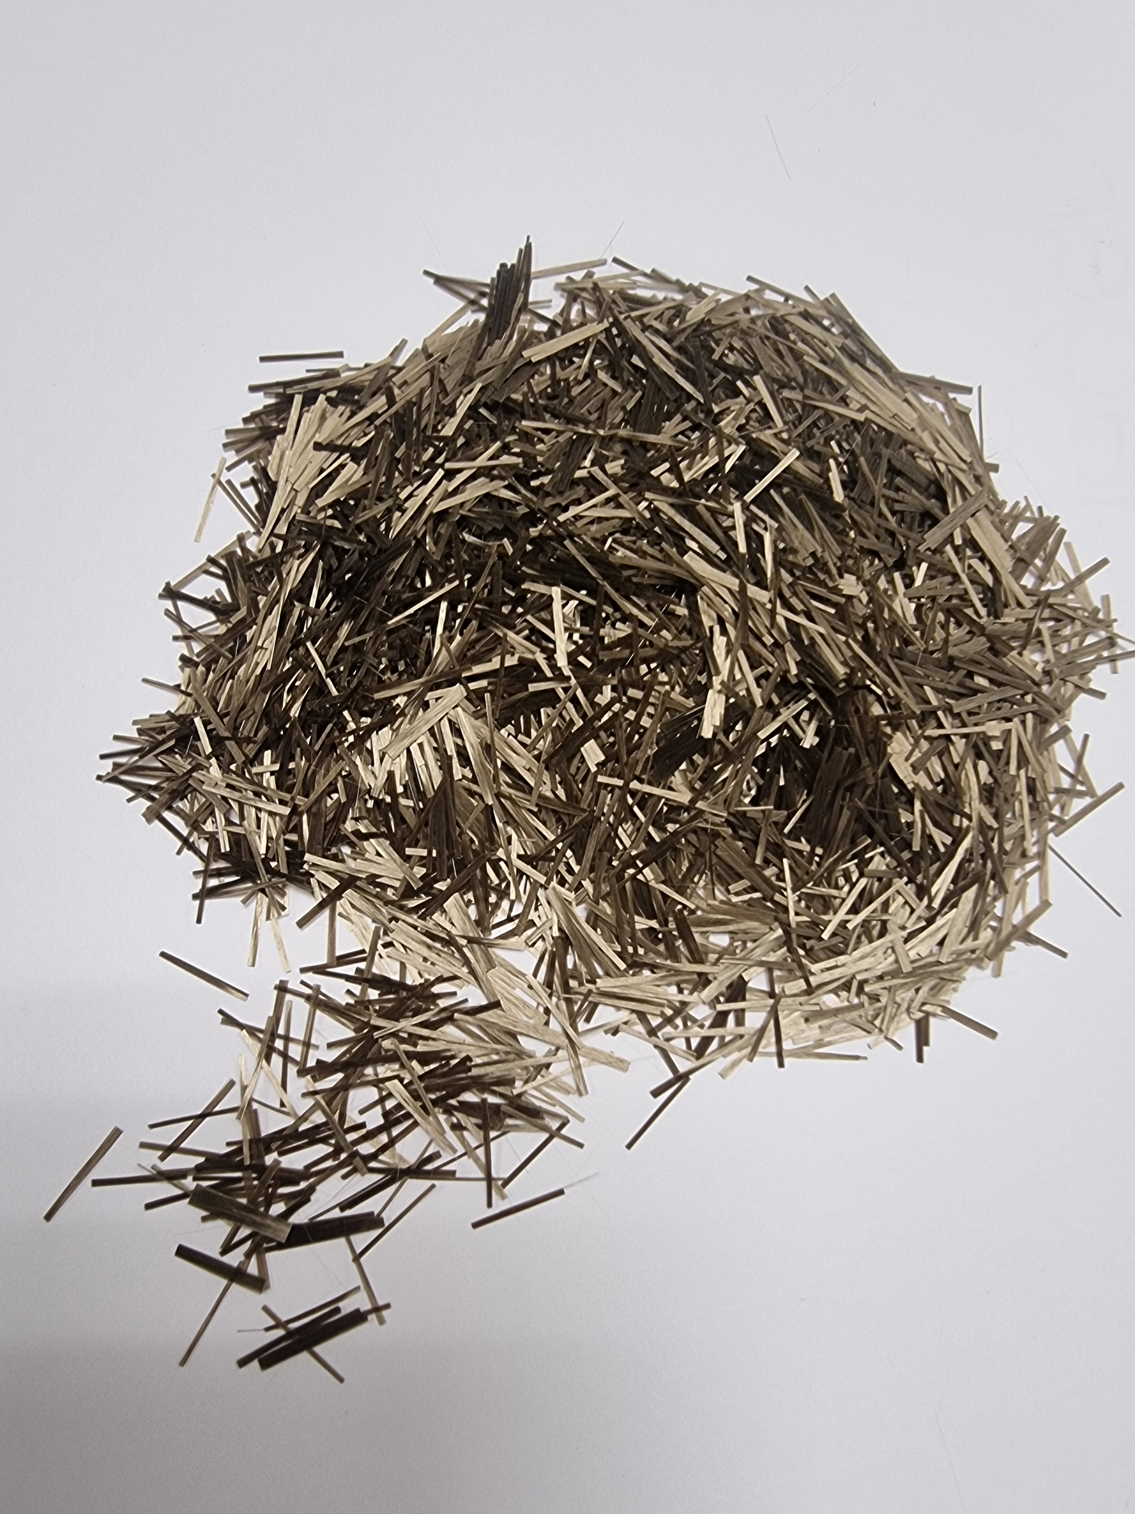

BFR-711



**Product description: BAS-DELTA 117 (13 / 17 my)**

**Available lengths: 3mm / 6mm / 12mm**

**Fiber specifications:**

**BFR-711 is a basalt chopped strand.**

**This product is coated with a silane-based sizing agent which is designed for compatibility with UP and acrylic resins.**

**BFR-711 has excellent resin wetting and fiber dispersion.**

**It is designed for application in panels. Basalt fiber can prolong its life, can improve its performance and can reduce the cost of the project, so it has a strong commercial value. This paper focuses on the short shear basalt fiber reinforced cement mix.**

**The product is added to the cement mix to improve the mechanical properties and service performance of the surface.**

**The addition of basalt fiber in the cement mix can improve fracture resistance and anti-ageing crack resistance to significantly extend the service life of the concrete artefact.**

**Product characteristics:**

* **Excellent mechanical property.**
* **Good static control and cuttability.**
* **Fast external wetting.**
* **Exceptional dispersion.**
* **Good stability at high temperatures.**
* **Good crack resistance at low temperatures.**

**Functional indicators:**

|  |  |  |
| --- | --- | --- |
|  | **Unit of measurement** | **Technical specifications** |
| **Thermal conductivity** | **W / (m · K)** | **0.030 - 0.038** |
| **Volume resistance** | **Ω · m** | **1 * 10 ^ 12** |
| **Chemical composition: total iron oxides** | **%** | **≥ 7.0** |

**Technical data sheet:**

|  |  |  |  |
| --- | --- | --- | --- |
|  | **Unit of measurement** | **Technical indicators** | **Test method** |
| **Tensile strength of immersed yarns** | **MPa** | **17 my = 2400**  **13 my = 2500** | **GB / T 20310** |
| **Fracture resistance** | **N/Tex** | **17 my: ≥ 0,4**  **13 my: ≥ 0,5** | **GB / T 7690.3** |
| **Elongation at break** | **%** | **≤ 3.1** | **GB / T 7690.3** |
| **Water content** | **%** | **≤ 0.1** | **GB / T 9914.1** |
| **Presence of fuel content** | **%** | **≤ 0.5** | **GB / T 9914.2** |
| **Density** | **g/cm3** | **2.6 - 2.7** | **ISO 1183-1** |
| **Oil absorption** | **%** | **≥50** | **-** |
| **Moisture content** | **%** | **≤0.2** | **-** |
| **Flammability** | **-** | **None** | **-** |
| **Heat resistance** | **%** | **≥85** | **-** |
| **Elasticity** | **GPa** | **≥80** |  |

**Packaging:**

**BFR-711 is available packed in 20 kg plastic bags in oktabin or pallets, or other packaging on request.**

**Basalt fiber is a brittle inorganic material, bending and contact with rough surfaces should be avoided and unnecessary friction reduced.**

**Storage:**

**BFR-711 should be stored in a dry, cool, moisture-proof area and should remain in its original packaging until used.**

**Validity:**

**BFR-711 remains valid for up to 12 months from the date of leaving the factory.**

**Technical parameters:**

|  |  |  |  |
| --- | --- | --- | --- |
| **Linear density (%)** | **Moisture content (%)** | **Size content (%)** | **Rigidity (mm)** |
| **ISO 1889** | **ISO 3344** | **ISO 1887** | **ISO 3375** |
| **± 5** | **≤ 0.10** | **0.6 ± 0.15** | **≥ 105** |

**Data parameters:**

|  |  |
| --- | --- |
| **Type of sizing** | **Silane** |
| **Filament (my)** | **13 / 17** |