

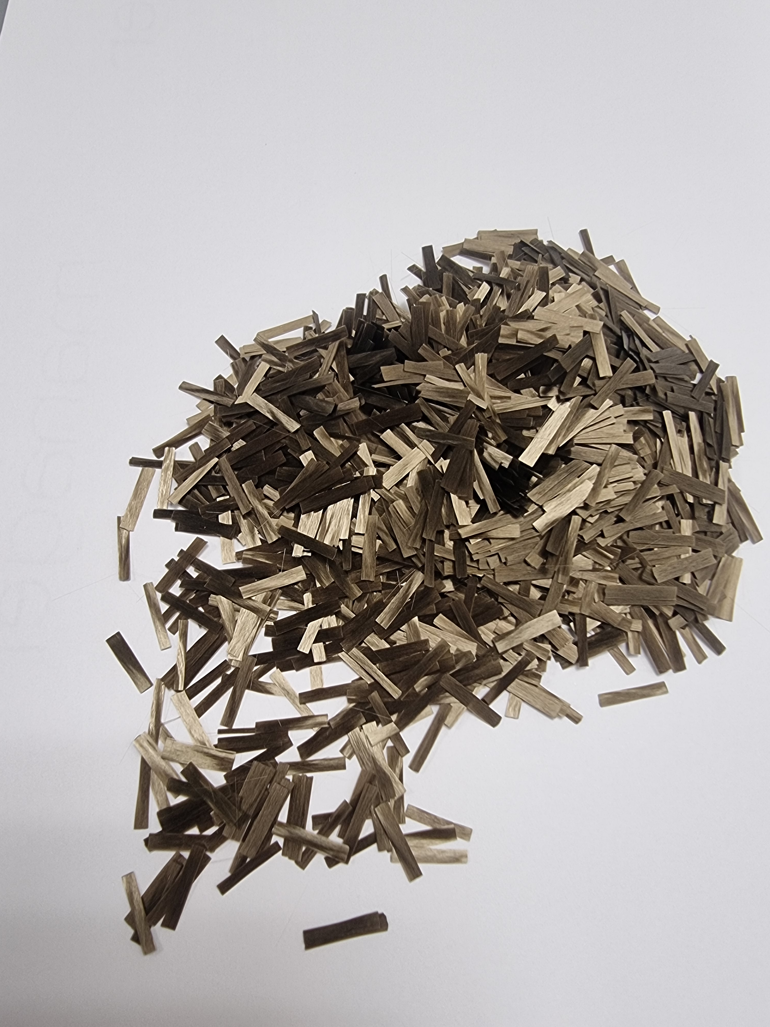

BFR-202



**Product description: BFR-202 (13 / 17 my)**

**Available lengths: 3mm / 6mm / 12mm**

**Fiber specifications:**

**BFR-202 are basalt chopped strand.**

**This product is coated with a silane-based sizing agent**

**It is designed for use in reinforcing asphalt and concrete mixes, both in new construction and revitalised projects. Basalt fibre can extend the life of the road and its surface, can improve its performance and can reduce the cost of the project, so it has a strong commercial value.**

**This paper focuses on the analysis of short cut basalt fibre and its properties.**

**This product is added to the asphalt and/or cement mix to improve the mechanical properties and service performance of the surface.**

**The addition of basalt fibre to the mix can improve pavement fracture resistance and anti-ageing crack resistance, thus significantly extending the service life of the pavement.**

**Basalt fibre is the best choice of reinforcement fibres for pavements, as they are quite unique and exclusive.**

**Product characteristics:**

* **Excellent mechanical property.**
* **Good static control and cuttability.**
* **Fast external wetting.**
* **Exceptional dispersion.**
* **Good stability at high temperatures.**
* **Good crack resistance at low temperatures.**



**Technical data sheet:**

|  |  |  |  |
| --- | --- | --- | --- |
|  | **Unit of measurement** | **Technical indicators** | **Test method** |
| **Tensile strength of immersed yarns** | **MPa** | **17 my = 2400**  **13 my = 2500** | **GB / T 20310** |
| **Fracture resistance** | **N/Tex** | **17 my: ≥ 0,4**  **13 my: ≥ 0,5** | **GB / T 7690.3** |
| **Elongation at break** | **%** | **≤ 3.1** | **GB / T 7690.3** |
| **Water content** | **%** | **≤ 0.1** | **GB / T 9914.1** |
| **Presence of fuel content** | **%** | **≤ 0.5** | **GB / T 9914.2** |
| **Density** | **g/cm3** | **2.6 - 2.7** | **ISO 1183-1** |
| **Oil absorption** | **%** | **≥50** | **-** |
| **Moisture content** | **%** | **≤0.2** | **-** |
| **Flammability** | **-** | **Niente** | **-** |
| **Heat resistance** | **%** | **≥85** | **-** |
| **Elasticity** | **GPa** | **≥80** |  |

**Functional indicators:**

|  |  |  |
| --- | --- | --- |
|  | **Unit of measurement** | **Technical specifications** |
| **Thermal conductivity** | **W / (m · K)** | **0.030 - 0.038** |
| **Volume resistance** | **Ω · m** | **1 * 10 ^ 12** |
| **Chemical composition: total iron oxides** | **%** | **≥ 7.0** |



**Data parameters:**

|  |  |
| --- | --- |
| **Type of size** | **Silane** |
| **Filament (my)** | **13 o 17** |

**Comparison of different fibres applied in asphalt pavements:**

|  |  |  |
| --- | --- | --- |
| **Name** | **Advantages** | **Disadvantages** |
| **Carbon fibre** | **improves resistance to high temperature, increases technological properties and improves crack resistance at low temperature.** | **It is expensive and difficult to disperse.** |
| **E-Glass fibre** | **Improve the property, strength and stability of asphalt.** | **Fragile, poor resistance to usury.** |
| **Synthetic and lignin fibres** | **Improve high temperature performance, low temperature crack resistance, water stability and fatigue resistance of the asphalt mix.** | **When the fibre content exceeds a certain value, the stability first increases and then decreases.** |
| **Basalt fibre** | **After the addition of the fibre to the asphalt mortar, the concentrated interface stress is released, the stress relaxation capacity is improved, the fatigue damage of the mix is significantly reduced, and the shear strength and erosion resistance modulus are improved.** | **None.** |

**Packaging:**

**BFR-202 is available packed in 20 kg plastic bags in oktabin or pallets, or other packaging on request.**

**Basalt fiber is a brittle inorganic material, bending and contact with rough surfaces should be avoided and unnecessary friction reduced.**

**Storage:**

**BFR-202 should be stored in a dry, cool, moisture-proof area and should remain in its original packaging until used.**

**Validity:**

**BFR-22 remains valid for up to 12 months from the date of leaving the factory.**