
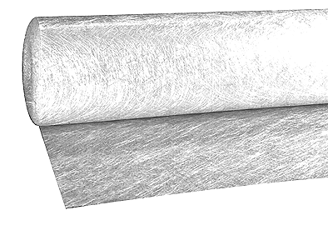

Emulsion

PropERTIES

■ Excellent compatibility with all types of polyester resins
■ Easy handling, good bubble releasing, very good "feel"
■ Good conformability
■ High strength of FRP products

A medium bulk chopped strand mat, manufactured from "E" glass fibres, coated with a silane base size. The glass filaments -12 µm and 30 tex- are chopped to approximately 50 mm and are distributed to give minimum orientation of the glass fibres. The chopped strands are bound together with an emulsion binder to form a porous mat that is white in colour.
easymat® is specially suited for parts requiring a good surface finish.

spécifications

Other grammages and widths are available upon request.

PACKAGING

STORAGE

easymat® should be stored dry in its original packaging.
Storage temperature : max. 35 °C – Relative moisture : < 70 %

FRP Services Europe reserves the right to change the information given herein without prior notice. We believe this information to be reliable, but do not guarantee its applicability to the user’s process or assume liability for occurrence arising out of its use. The user, by accepting products described herein agrees to be responsible for thoroughly testing any application before committing to production.
January 2020
FRP Services Europe reserves the right to change the information given herein without prior notice. We believe this information to be reliable, but do not guarantee its applicability to the user’s process or assume liability for occurrence arising out of its use. The user, by accepting products described herein agrees to be responsible for thoroughly testing any application before committing to production. January 2020

